**1. Solace Appliance :**

Solace appliance is a device that provides high throughput, end-to-end messaging across the core, edge and device layers of typical IoT architectures. It is a turnkey rack-mounted device which is easy to deploy, manage and upgrade over time.

A Solace PubSub+ appliance uses two types of physical Ethernet interfaces:

* Management interfaces and
* NAB interfaces.

**Hardware Features :**

The Solace PubSub 3560 Event Message Broker Appliance is a high-performance, enterprise-grade message broker that offers a wide range of features and functionalities. Some of the key features include:

* **Safety approvals:** The appliance meets a variety of safety standards, including IEC 60950-1, CSA 22.2 No. 60950-107, FCC Part 15 Clam A, EN 55032-2012, EN550242012, EN 61000-3-2.2014, and EN 61000-3-3-2013.
* **EMC approvals:** The appliance meets a variety of EMC standards, including EN 55032-2012, EN550242012, EN 61000-3-2.2014, and EN 61000-3-3-2013.
* **Interfaces:** The appliance supports a variety of interfaces, including Ethernet 1000, Fore Channel 44 Gbps, and RS232.
* **Network protocols:** The appliance supports a variety of network protocols, including Ethernet IEEE Std 8012, Ethernet IEEE Std 80234, and Ethernet Link Ac IEEE Std 802.3ad.
* **Message exchange patterns and QoS:** The appliance supports a variety of message exchange patterns and QoS levels, including point-to-point, fanout, streaming, and persistent delivery.
* **High availability:** The appliance offers high availability with 99.999% availability for an appliance, active-active or active-standby mode, chassis-based system with discrete data and control planes, and integrated replication for disaster recovery.
* **Security:** The appliance offers a variety of security features, including per-cent authentication, TLS encryption, and inter-broker security.
* Monitoring & management: The appliance can be managed via CLI, SAdmin GUI, SEMP/STAP, and Web. It also supports publisher, subscriber, and manager layer access control lists.
* **Distribution:** The appliance supports load balancing and guaranteed delivery for WAN between data centers. It also offers hands-off management.
* **Other:** The appliance includes an integrated TRS plugin for Solace monitoring, per topic, per subscriber rate controlling for consumers who can't consume messages, last value caching with all request/reply semantics, and message compression with clients and/or between brokers.
* **Virtualization:** The appliance can virtualize application groups on the same physical Solace message roster with deep dependent and perimeter message stats from layers 1-7.

**2. Racks :**

A rack is a supporting framework for holding hardware modules in IT (Information Technology), typically containing servers, hard disk drives, and other computing equipment. The standard size is nineteen inches, with the ETSI standard being 23 inches.

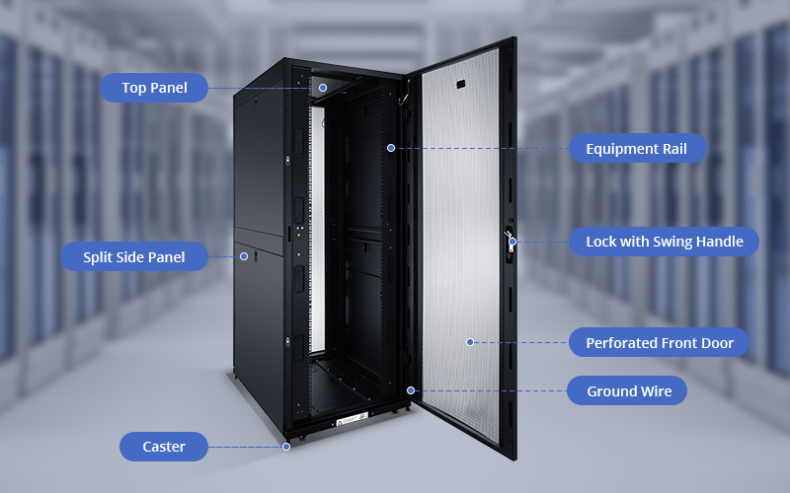

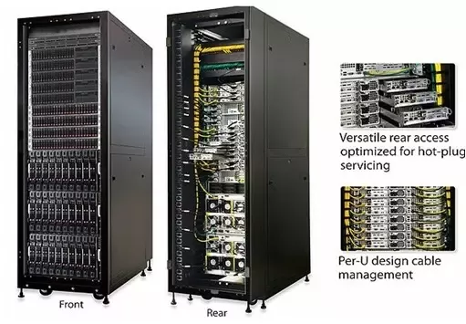

Racks have multiple bays for holding hardware units. They are commonly used in data centers, server rooms, ISP, telecommunication, and computing facilities. Alternatives include tower servers and blade servers. Hyper-converged infrastructure is a newer technology that integrates compute, storage, networking, and virtualization resources within a single physical device.

**Types of Racks :**

There are three primary types of racks:

(i) open frame racks,

(ii) rack enclosures, and

(iii) wall-mount racks.

**Open frame racks** : are open frames without sides or doors, ideal for high-density cabling applications with convenient access and open space for cable management. They can have two or four vertical mounting rails (posts), supporting less weight but requiring less available depth.

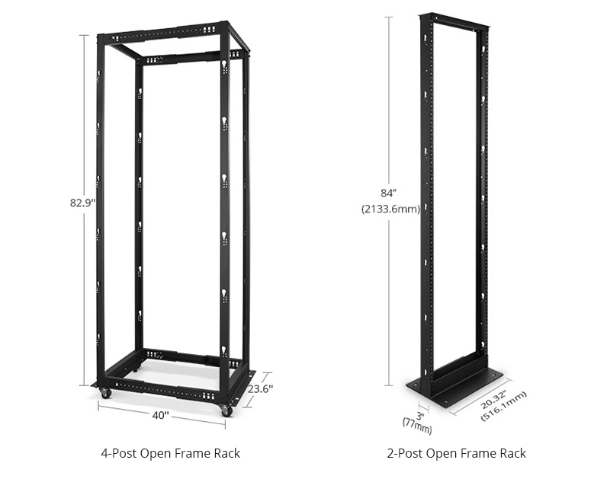 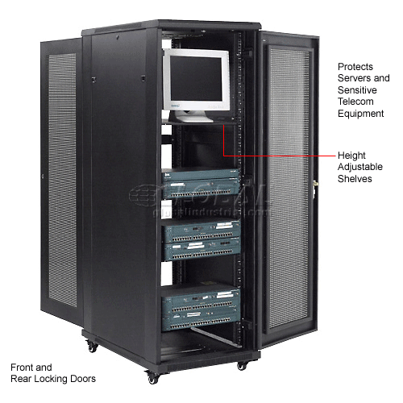

**Open Frame Rack Rack Enclosures**

**Rack enclosures** : also known as rack cabinets, have removable front and rear doors, removable side panels, and four adjustable vertical mounting rails. They are ideal for heavier equipment, hotter equipment, and higher wattages per rack. Enclosures can be configured without doors and/or side panels for open frame applications with higher weight capacities.

**Wall-mount racks :**  are designed to be attached to the wall, saving floor space and fitting in areas where other racks cannot. They can be open frame racks or enclosed cabinets, but are smaller and can't support as much weight. Wall-mount racks can be adapted to floor-standing applications by adding rolling casters.

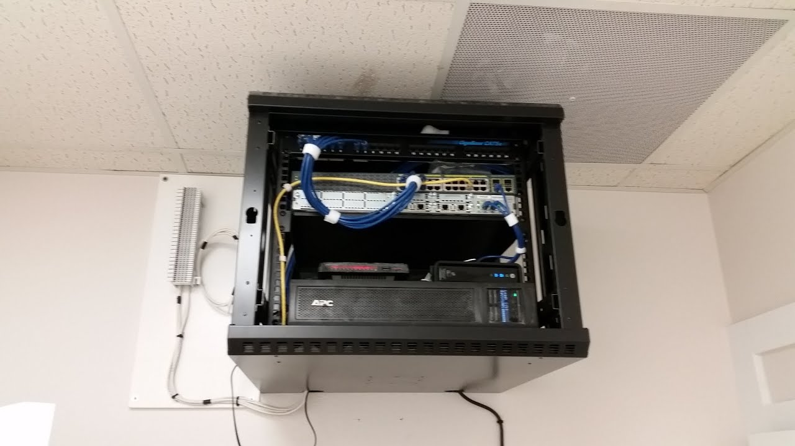

**FPGA :**

Field Programmable Gate Arrays (FPGAs) are semiconductor devices that are based around a matrix of configurable logic blocks (CLBs) connected via programmable interconnects. FPGAs can be reprogrammed to desired application or functionality requirements after manufacturing. This feature distinguishes FPGAs from Application Specific Integrated Circuits (ASICs), which are custom manufactured for specific design tasks. Although one-time programmable (OTP) FPGAs are available, the dominant types are SRAM based which can be reprogrammed as the design evolves.

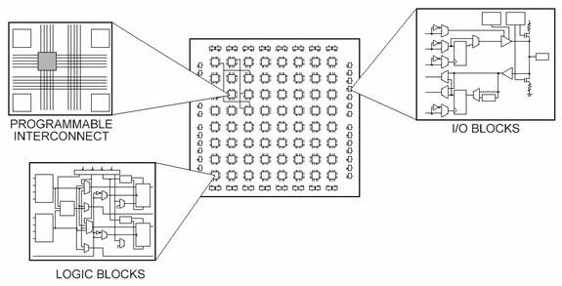

**The Different Parts of an FPGA**

Every FPGA chip is made up of a finite number of predefined resources with programmable interconnects to implement a reconfigurable digital circuit and I/O blocks to allow the circuit to access the outside world.

FPGA resource specifications often include the number of configurable logic blocks, number of fixed function logic blocks such as multipliers, and size of memory resources like embedded block RAM. Of the many FPGA specifications, these are typically the most important when selecting and comparing FPGAs for a particular application.

The configurable logic blocks (CLBs) are the basic logic unit of an FPGA. Sometimes referred to as slices or logic cells, CLBs are made up of two basic components: flip-flops and lookup tables (LUTs). Various FPGA families differ in the way flip-flops and LUTs are packaged together, so it is important to understand flip-flops and LUTs.

**Features:**

FPGA fabric offers infinitely configurable capabilities, allowing programmers to design FPGAs for various functions. Its parallel nature allows for high throughput and parallel processing, making it ideal for measurement systems and edge computing applications. FPGAs can be reconfigured for updates or feature additions, unlike ASICs, which can be expensive. They are typically used for low to medium volume production, while ASICs are preferred for high volume products due to lower costs. FPGAs also offer a quick turn-around time from concept to production, as no actual design at the transistor level is needed.

**Different planes in network :**

In networking, the term "planes" is often used to refer to different functional components or layers within a network device or architecture. These planes help organize and categorize the various tasks and responsibilities of a network system. Here are some common planes in networking:

1. **Control Plane:** The control plane is responsible for making decisions about how data traffic should be forwarded through the network. It involves tasks such as routing, managing routing protocols, updating forwarding tables, and maintaining network topology. The control plane ensures that devices know how to reach each other and make intelligent routing decisions.

2. **Data Plane (Forwarding Plane):** The data plane, also known as the forwarding plane, is responsible for the actual forwarding of data packets. It includes the hardware and software mechanisms that move data packets from input ports to output ports based on the information stored in forwarding tables set up by the control plane.

3. **Management Plane:** The management plane is responsible for the configuration, monitoring, and management of network devices. It allows administrators to set up and modify network settings, monitor device performance, and troubleshoot issues. This plane ensures that the network is properly configured and operational.

4. **User Plane:** The user plane is the portion of the network responsible for carrying user-generated traffic. It includes the data traffic between end devices, such as user applications, client-server interactions, and multimedia content.

5. **Data Center Network Planes:**

- Application Plane: In data center networks, the application plane refers to the layer where applications and services reside. This includes virtual machines (VMs), containers, and other application instances.

- Tenant Plane: In multi-tenant environments, the tenant plane isolates the resources and data of different tenants or customers.

- Overlay Plane: Overlay networking creates logical network segments that are independent of the physical infrastructure. The overlay plane handles the encapsulation, tunneling, and routing of overlay traffic.

6. **Service Plane**: In carrier-grade networks, the service plane is responsible for providing various network services, such as Quality of Service (QoS), traffic engineering, and security services.

7. **Orchestration Plane:** In software-defined networking (SDN) and network function virtualization (NFV), the orchestration plane manages the provisioning and configuration of network resources and services dynamically.

It's important to note that these planes are conceptual divisions used to describe different network functions. In real-world networking devices, these planes may be implemented using a combination of hardware and software components. The clear separation of planes allows for better scalability, maintainability, and flexibility in designing and managing complex networks.

**3. NAB (Network Acceleration Blade) :**

NAB stands for Network Acceleration Blade. [It is a blade that is installed in one of the fabric expansion slots at the rear panel of a Solace PubSub+ appliance](https://docs.solace.com/Admin/IP-Interfaces/Appliance-Interfaces.htm). [The NAB interfaces are physically located on the NAB and the number of physical Ethernet ports on a NAB depends on the model of NAB installed in the appliance](https://docs.solace.com/Admin/IP-Interfaces/Appliance-Interfaces.htm)

**NAB Replacement :**

The following tools and equipment are required to replace a NAB in a appliance:

* electrostatic discharge wrist strap
* anti-static mat
* anti-static packaging for the NAB
* No. 1 Phillips head screwdriver (PubSub+ 3260s with FEC CHS-FC1040-01-C or CHS-FC0140-01-B)
* No. 2 Phillips head screwdriver (PubSub+ 3560s)
* a replacement NAB (provided by Solace)

we can replace one model of NAB with another model NAB that has fewer Ethernet ports. For example

* an eight-port GigE NAB (NAB-0801ET) with a two-port 10GigE NAB (NAB‑0210EM)
* a NAB-0801ET with a six-port 10GigE NAB (NAB‑0610EM)
* a NAB-0610EM with a NAB‑0210EM

To replace one model of NAB with another model NAB that has fewer Ethernet ports (NAB configurations ) :

* Step 1: Backup Current Configuration

Before making any configuration changes, back up the current event broker configuration.

* Step 2: Make Required Configuration Changes
  + - LAG Configuration:
      * Only one LAG is supported per interface.
      * When using a two-port NAB, remove extra LAGs (3 and above) beyond lag2.
      * Failure to remove extra LAGs may lead to errors and appliance restart.
    - Bridge Configuration:
      * When replacing NAB with fewer ports, adjust Message VPN Bridges to avoid using invalid interfaces.
    - Replication Configuration:
      * When changing to a NAB with fewer ports, update Replication settings to avoid using invalid interfaces.
    - Message Backbone VRF:
      * For NAB replacement with fewer ports, deactivate and delete IP interfaces under Message Backbone VRF for unused ports.
    - IP Interface Configuration:
      * When switching to a NAB with fewer ports, deactivate IP interfaces for unused ports.
    - Routing Interface Configuration:
      * For NAB change with fewer ports, adjust routing setup to avoid using invalid interfaces.
* Step 3: Reload Event Broker Configuration

After making the necessary configuration changes, reload the event broker configuration

* Step 4: Backup Event Broker Configuration

Back up the reloaded configuration.

* Step 5: Power Down Appliance

Power down the appliance.

* Step 6: Physically Change Out NAB

**Steps to Physically Change Out NAB :**

1. Turn off the appliance
2. Identify Blade Carrier to Remove
3. Remove Blade Carrier from Chassis
4. Remove Blade from Blade Carrier
5. Install Replacements and Reinsert Carrier
6. Reattach Top Cover
7. Restore Power to Appliance